USER’S GUIDE TO PRECALC (Avis) and BQUIKCAL (Budget)

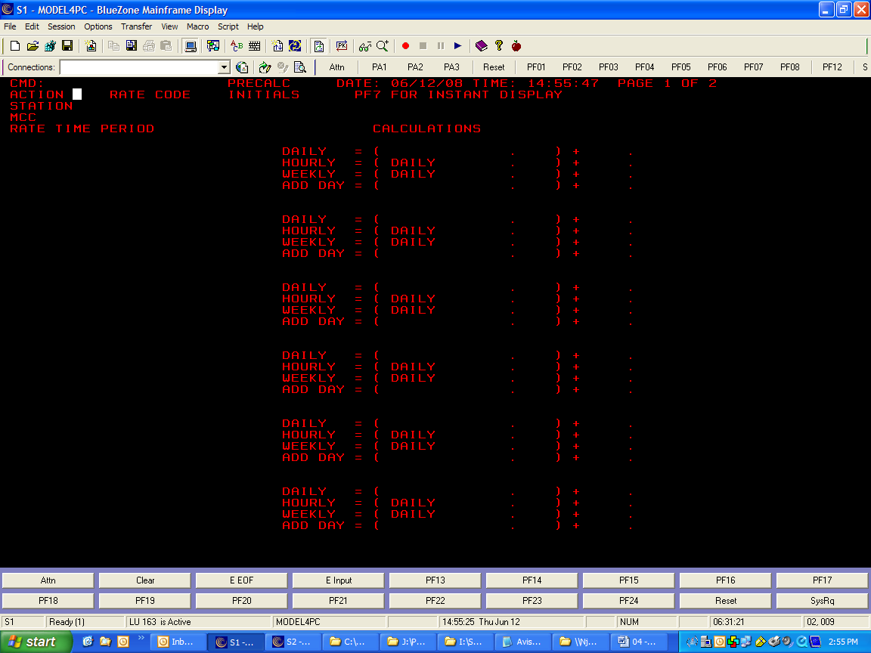
SCREEN ACTIONS

DISPLAY (DIS)

To display a precalc screen:
- Type: /FOR PRECALC – AVIS
- Type: /FOR BQUIKCAL – BUDGET

To display calculations:
- Action: DIS
- Rate Code: Type in the desired rate code (up to 2 characters)
- Station: Type in the desired station number, i.e. 00405 (up to 12 stations)
- Press ENTER twice or hit F7 for an instant display. There are two screens for each display. Each screen holds calculations for up to six time periods (hence a maximum of twelve time periods for each rate code). It will say PRESTO RATE CALCULATIONS DISPLAYED

Note: The current time period will be the first one displayed. The rest of the time periods will follow in date order.
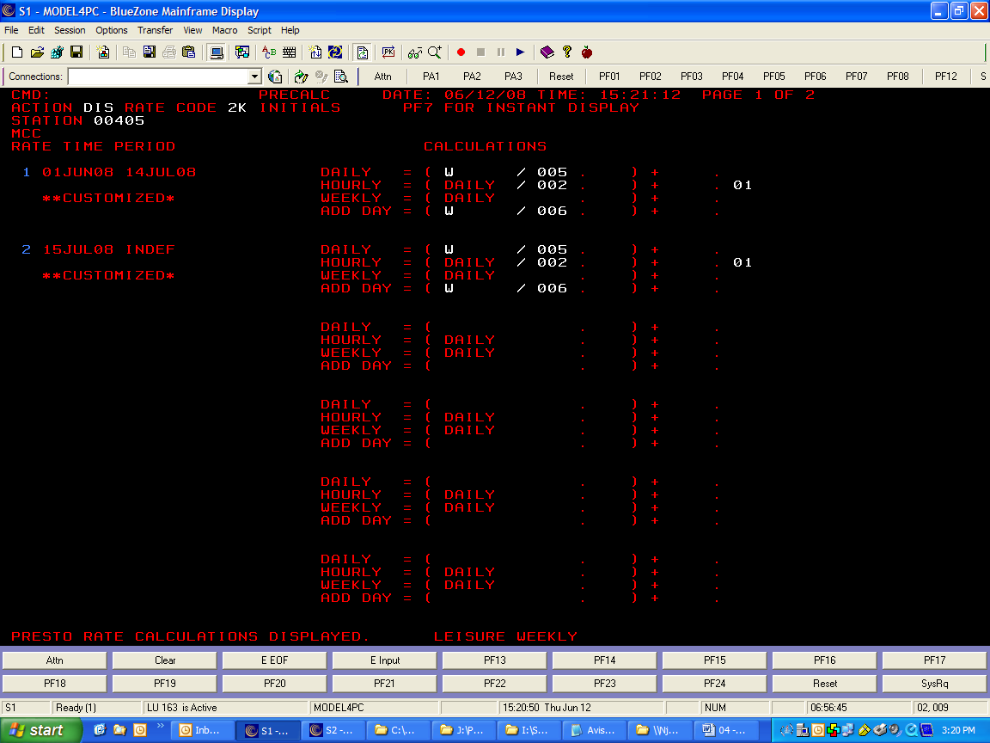

Messages:
- THE FOLLOWING RATE PAIR DATES DO NOT MATCH: XXX…
This means that the display was successful. However, PRECALC has detected blank-rate and x-rate pairs that do not have exactly the same effective and termination dates. The incorrect pairs are listed by the numbers where the X’s are in the statement above. For example, if X were equal to “3”, then by locating Date Pair #3, you would see the effective and/or termination date(s) below the blank-rate date ranges that are incorrect.

- PRESTO RATE CALCULATIONS DISPLAYED.
This means that PRECALC has found and displayed the requested rate calculations and that all date pairs match.

- RATE NOT FOUND AT THIS STATION
This means that PRECALC could not find the requested rate at the requested station. Make sure that the rate code is loaded at the station you entered.

- NO COMMAND ENTERED. ENTER DIS, MOD, ERR, OR PRT ONLY
This means there was nothing typed next to ACTION. Go back and put in the correct command.

- INVALID DATA HAS BEEN ENTERED. PLEASE CORRECT FIELDS MARKED BY ?’S.
This means an entry field has incorrect or invalid data in it. The field that has the incorrect data will have question marks as entries.
SCREEN ACTIONS

MODIFY (MOD)

To modify calculations for a Rate:
  - Make sure the rate is displayed first.
  - Action: MOD
  - Enter your initials into the INITIALS field.
  - Change the calculations on the screen.
  - ENTER twice. It will say RATES AND RATE CALCULATIONS MODIFIED at the bottom of the screen. (see screen shot below)
  - Do a Display Action (DIS) to ensure the change went through

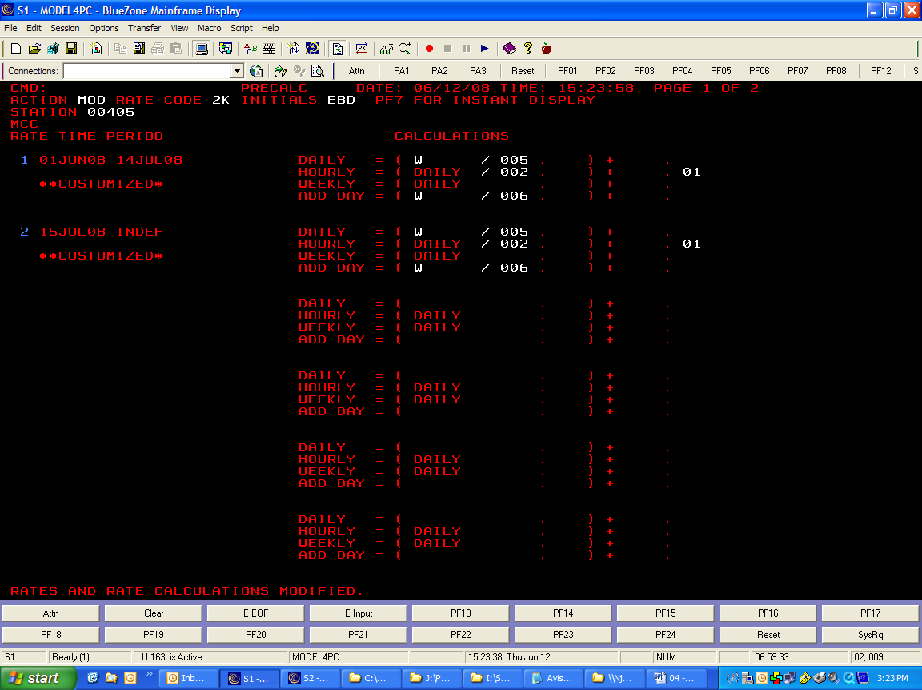

Messages:
- A DIVISION HAS RESULTED IN AN ERROR. CHECK DIVISION VALUES.
The factors you have entered have resulted in a division error. Review your division entries for possible errors.

- A NEGATIVE RESULT HAS BEEN CALCULATED. CHECK SUBTRACTION VALUES
The factors you have entered resulted in a negative value. Review your subtraction entries for possible errors.

- AN OVERFLOW CONDITION HAS OCCURRED. MULTIPLICATION VALUES TOO LARGE.
The factors you have entered resulted in a product larger than Rate Database can hold. Review your multiplication entries for possible errors.

- AN OVERFLOW CONDITION HAS OCCURRED. ADDITION VALUES TOO LARGE.
The factors you have entered resulted in a sum larger than Rate Database can hold. Review your addition entries for possible errors.

- COUNTRY CODE NOT VALID FOR PRESTO
For tier rates, the stations must be in countries valid for PRESTO. These countries are Canada, US, Puerto Rico, and the Virgin Islands.

- INVALID DATA HAS BEEN ENTERED. PLEASE CORRECT FIELDS MARKED BY ?’S.
An entry field has incorrect or invalid data on it. The field is indicated by question marks in it.

- MODIFY REQUIRES A DISPLAY OF THE STATION FIRST.
You must display the station you wish to modify before you attempt to modify it.

- MUST ENTER INITIALS FOR MODIFY.
You must enter your initials in order to modify any fields in PRESTO.

- NOT ALL STATIONS UPDATED; TYPE ERR IN ACTION NOW TO SEE ERRORS – TRAN: XXXX
You have requested a multiple station update. However, all of the stations you have requested do not have the same time periods. A list of these errors is available through the Error function. See section on Error function for more.

- RATES AND RATE CALCULATIONS MODIFIED.
All transactions went through successfully. Calculations and rate values were changed.

- SIGNON NOT AUTHORIZED FOR THIS STATION…REQUEST DENIED.
Your sign-on is not authorized for the stations. If you are trying to change a domestic location, first check the station number. If it is typed correctly, you may not be signed into the correct p601 screen.

- STATION NOT FOUND ON LDB. CONTACT TSS.
The station you have requested either does not exist or you have entered it incorrectly.

- STATION NOT ON HDB. CONTACT TSS.
While PRECALC was trying to validate the station you have requested for security, it has encountered a problem with the number you have entered. Either you have incorrectly keyed the station or there is a problem in the hierarchy database.

- STATIONS MUST BE IN THE SAME COUNTRY…REQUEST DENIED.
The PRESTO system requires that on multiple station updates, all the station that are to be changed must be in the same country.
SCREEN ACTIONS

ERROR (ERR)
To View Error Listings of Multiple Updates:
METHOD 1:
- Immediately after receiving the error message, type ERR in ACTION
- Press ENTER.
- This will automatically retrieve the error record from the previous action.
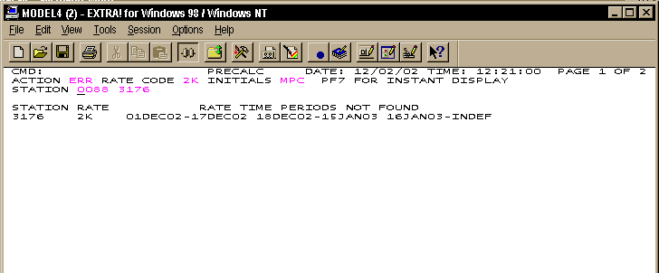

METHOD 2:
- Make sure to note the TRAN number after receiving the error message.
- Type ERR in ACTION
- Type the TRAN number in STATION
- This will allow you to view any error record produced during the current day. These errors reports will be transferred to a paper report at the end of the day.

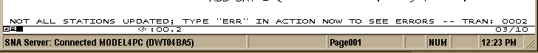
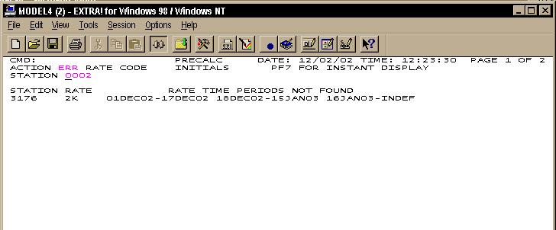
SCREEN ACTIONS

PRINT (PRT)

To print PRECALC screens:
- Enter PRT in ACTION.
- Hit ENTER
- PRECALC will issue a message back stating whether the transaction was successful or not.

Messages:
- DISPLAY PRINTED ON PRINTER: XXXXXX.
This means the screens you requested have successfully printed to printer “XXXXX”

- PRINTER NOT FOUND…DISPLAY NOT PRINTED.
This means your terminal is not assigned to a printer. Assign the Terminal to a printer.
PRECALC DEFAULT CALCULATIONS
AND DEFAULT RULES

 | Canada | United States
Daily | W = D * 5 | W = D * 5
 | H = (D / 2 ) + 0.01 | H = (D / 2 ) + 0.01
Weekend | AD = D + 30 | AD = D + 30
Weekend | W = D * 15 | W = D * 15
Weekend | H = (D / 2 ) + 0.01 | H = (D / 2 ) + 0.01
Weekly | D = W / 3 | D = W / 3
Weekly | AD = W / 4 | AD = W / 4
Weekly | H = (D / 2 ) + 0.01 | H = (D / 2 ) + 0.01
Monthly | D = M / 21 | D = M / 21
Monthly | W = D * 7 | W = D * 7
Monthly | H = (D / 2 ) + 0.01 | H = (D /2 ) + 0.01

Where: W = weekly, D = daily, H = hourly, AD = additional day, M = monthly

NOTE: The daily calculation for both the weekly and monthly rates are rounded to the nearest dollar

How Default Calculations are Applied:
- In PRESTO, when a rate has been modified, PRESTO checks to see if the user has defined a calculation formula. If no user defined calculation exists, PRESTO applies the above calculations.
- In PRECALC, when a change is made to the calculations displayed, PRECALC updates the stored calculations and applies the new calculation to the rate. If a mod is requested with default values only, PRECALC removes any stored calculations and applies the default calculations to the rate.
- In PRECALC, if the user removes all calculations from a rate, PRECALC removes the stored calculations and applies the default calculations to the rate.
- In RTEMO1, the MODP action will apply any user defined calculation to any changes made to a rate. If no user defined calculation exists, RTEMO1 will apply the appropriate default rules to the rate. RTEMO1 will only apply these calculations to rates in current PRESTO countries.

